Moved in in 2006 – number 8 resident (Tania)

Establishments in the area:

Ballroom

Bramleys

Tiki Bar

Thomas Becket

Seven Stars

*Q*

Tania: (spent a period of time away) Below was in 2006

* Orange street music club (not so bad – Now Ballroom)
* Cocktail bar (now Tiki Bar)
* Bramleys opened
* Problem with venue called Bar Candy
  + A lot of noise from this venue inside and out
  + Called to review by residents because of video evidence being taken into account – which resulted in reduced hours

Last year:

* Worst year
* Orange Street reached a “tipping point”
* The venues in the area resulted in people hanging around I the street late at night

TENS: Temporary Event Notice <https://www.gov.uk/temporary-events-notice>

* Places can be open later
* They can happen whenever
* Different restrictions apply to the places than normal licence laws
* Can stay open later (4am)

“Stops me enjoying/using my home”

noise could start from around 7:30pm – 8pm

It's not the residents fault if the windows need to be open, as it is a general use of a home

Main issues: music/people/general noise

* Side issue broken glass (does not really affect the project)

When clubs apply for longer licences:

* Residents need to demonstrate level of inconvenience
* If you don’t complain the licence will be allowed to be extended (usually)
* Makes residents feel like “busybodies”
* From 7 Friars resident Kevin: If you make complaints maybe 1 out of 10 gets a response
* Must show body of evidence
* Regular complaining without evidence making the residents seen as nuisances – meaning that they haven’t complained as much making them worried that it is going to get noisier

Ballroom not as busy of late possibly because of the Pound

Lingangs (older neighbours across the street) and the whole street would like to be involved

Ideal solution:

* Maintainable equipment that can be used in the long term
* They don’t want this to just run for a year because they will need to make a judgment call as to whether this is the year to present their data because things could get worse.
* Owners do not mind a bit of noise or noise on the odd day
* Kevin (Music Producer) used recording equipment one night and compared it to being outside at an airport at 110dB

They have a perception of a lot of noise along the street at all times

Concern: If we leave the project will it continue? (Is there a possibility of it being sustained?)

*Q*

It is pretty much noisy every night “every night (laughing)”

There have been pub crawls in the previous weeks

If you were involved in the event you wouldn’t think about the residents because they are “just people having a good time” they aren’t violent or aggressive

There are generally people messing around in the street it could be considered a “party street”

It's more from people coming out of venues, it is not necessarily people walking through

Everyone in the street is affected by the noise

As an example there was an event (possibly freshers) it was like a “drunken athletics event” where they were using a whistle to start races down the street, it was constantly being blown at 2am

Seb who owns 14 Orange Street rents to tenants, the house is right next to the ballroom and already the new tenants are complaining

“The street is used as an extension of the venue” – people queuing, drinking and smoking

There was a night when a group of 20 – 40 people sat on the steps of the Marlowe from one of the pubs while drinking and someone playing music.

On a night where it is nice enough to do that it's okay in their eyes (even if people from the venues should not be using it as an extension of their pub) but not at the determent of everyone else.

Talked about possible solutions for a while:

Unfeasible: using the disabled car park behind where the Tiki is as extra space for clientele. Approached the council about this but they were worried people would be selling drugs to each other round there.

Not entirely relevant to what we are doing: Using community police officers of a night time. Police tell residents not to go out of their house to tell people to be quiet as it might be dangerous. The residents were also looking for some enforcement of noise laws.

Impractical but feasible: a sign saying how loud it is akin to speeding signs on the road (feel this would be seen as more of a challenge to a crowd of drunk people not a deterrent)

“people are just talking loudly because they are drunk” There is nobody to enforce behaviour for a mixed (residential and commercial) neighbourhood

Feasible but unobtainable in our time frame: showing sound levels to a hub at a police office so noise disturbances could be attended to that way.

Doors opening and closing constantly is a problem, as sound escapes when it is open, which could be seen as more annoying than hearing a whole song. Average noise measurements are taken from when the doors are closed and this is not taken into account.

*Q*

Noise comes from every direction

Possibly 90% from venues and 10% from people walking through



Orange street Friars

Bramleys not so much of a problem

New Greek restaurant asked why the residents don’t complain about the noise

Thomas Becket is okay

The Marlowe is not an issue either (different kind of clientele)

Tania is friends with the ballroom owner who has tried to bring the level of the bass down as it can sometimes be felt through the walls

“Shouldn’t be able to shazam a song from her room while trying to get to sleep”

SIDE NOTE: would be a good idea if we could split frequencies to see what is bass etc

*Q*

They are happy for us to use their wifi and power

Should be a closed experiment not telling the venue owners because they don’t want them to alter their behavior while being monitored

Not interested in catching anyone out

Client imagining of how they would like to see the data

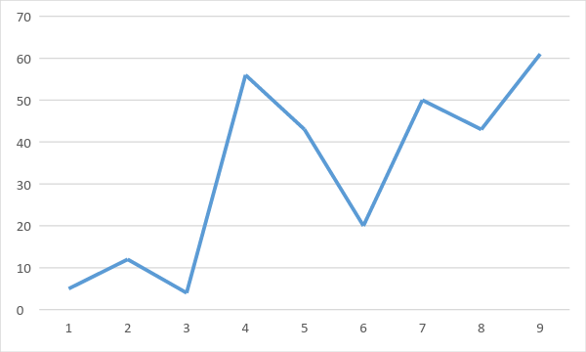

They won't have to complain constantly and they will have data

They are happy to be changing batteries (they are expecting some kind of maintenance akin to a router)

Some way of telling them if something has gone wrong

Would like a readily available view, with ease of access

“burden of proof on residents gone”